Tiny Trail - A Digital Market Place From Home To Your Hands

Ms. N. Hindumathy M.E,,
Department of Computer Science and Engineering,
Vel Tech High Tech Dr. Rangarajan Dr. Sakunthala Engineering College, Tamil Nadu, India hindumathy.n@velhightech.com

Thirumurugan B,
Department of Computer Science and Engineering,
Vel Tech High Tech Dr. Rangarajan Dr. Sakunthala
Engineering College, Tamil Nadu, India
vh12436_cse22@velhightech.com
Thiso Vallabadass K,
Department of Computer Science and Engineering,
Vel Tech High Tech Dr. Rangarajan Dr. Sakunthala Engineering College, Tamil Nadu, India
vh12437_cse22@velhightech.com

Sabarinathan S,
Department of Computer Science and Engineering,
Vel Tech High Tech Dr. Rangarajan Dr. Sakunthala Engineering College,Tamil Nadu, India vh12404_cse22@velhightech.com

Abstract - The "Tiny Trail – A Digital Market Place from Home to Your Hands" project offers a systematic framework for hyperlocal commerce that aims to digitally incorporate the unorganized sector into contemporary marketplace ecosystems. Large-scale e-commerce platforms have simplified organized retail by using centralized logistics and regulatory compliance models, but strict GST regulations, static storefront assumptions, and weak trust mechanisms continue to exclude millions of micro-entrepreneurs, such as street vendors, home-based food sellers, and small-scale artisans. The proposed solution replaces binary inclusion models with a graduated responsibility framework by introducing a Tiered Trust Architecture that allows progressive vendor onboarding through community verification, licensed certification, and complete compliance tiers. The technology incorporates real-time vendor monitoring with Firebase's cloud-based synchronization infrastructure to overcome mobility issues, enabling dynamic geospatial discoverability within an operational radius of 1-2 km. The solution also includes an AI-assisted Hygiene Validation process for food vendors, which improves consumer trust and transparency by creating daily confidence indicators from workplace image submissions.With the help of Flutter and Firebase services, the architecture guarantees safe cloud storage, scalable authentication, low-latency data synchronization, and economical micro-logistics without the need for conventional server-side infrastructure administration. In order to prevent algorithmic domination by big suppliers and prioritize locality-based demand patterns, the platform also uses pincode-centric product discovery. In hyperlocal areas, experimental deployment shows enhanced consumer involvement, better vendor exposure, and a stronger sense of confidence. For informal micro-commerce ecosystems, the suggested framework creates a digital infrastructure model that is inclusive, scalable, and repeatable.
Keywords— Hyperlocal Marketplace, Tiered Trust Model, Informal Sector Digitization, Real-Time Geospatial Tracking, AI-Assisted Hygiene Scoring, Food Inventory Expiry Management, Pincode-Based Discovery, Firebase Cloud Architecture.
- INTRODUCTION
Around the world, established retail ecosystems have undergone significant change due to the quick development of digital commerce platforms. Payment processing, consumer engagement strategies, logistics, and regulatory compliance are all standardized in centralized markets. The unorganized sector, which includes street vendors, home-based food entrepreneurs, small-scale craftspeople, and mobile service providers, is still largely shut out of official digital involvement despite these advancements. Static storefront assumptions, strict compliance standards, and a lack of trust structures specifically designed for informal micro-enterprises are the main causes of this exclusion.The architecture of traditional e-commerce systems is designed to support structured supply chains, stable business locations, and Goods and Services Tax (GST) registration. On the other hand, a significant percentage of micro-business owners function without official documents, centralized inventory systems, or permanent addresses. As a result, scalability and internet visibility are limited, and their economic activity is still limited to physical communities and word-of-mouth discovery.Therefore, the informal economy's digitization challenge is structural rather than just technological. Current platforms use binary eligibility models, where vendors are either excluded completely or meet regulatory requirements. Micro-entrepreneurs, who make a substantial contribution to local economic circulation but are not fully formalized, are disproportionately affected by such strict regulations. In order to facilitate dynamic, low-radius informal commerce, this study suggests TinyTrails, a mobile-first hyperlocal marketplace architecture. Three main structural issues are intended to be addressed by the system:
Vendor Mobility: Modeling vendors as dynamic geographic objects instead of fixed storefronts.
Graduated Compliance: Applying a Tiered Trust Architecture that correlates levels of operational transparency with levels of verification instead of binary inclusion schemes.
Consumer Trust Transparency: Offering food vendors organized quality metrics via AI-enabled hygiene rating processes.
The proposed solution enhances neighborhood commerce networks and reduces logistical costs by constraining marketplace discoverability to a 1-2 km operational range. The system leverages Firebase cloud infrastructure for real-time synchronization, authentication, geolocation, and data storage, as well as Flutter for mobile app development.
The primary aim of this research work is to propose and evaluate a scalable framework for hyperlocal commerce that enables inclusive digital participation without compromising regulatory rigor. The framework redefines compliance norms using a tiered liability framework that enables progressive vendor inclusion, as opposed to relaxing norms.
Using this approach, TinyTrails aims to demonstrate that geographic modeling, architectural design, and transparency design principles can collectively contribute to substantial digitization of the unorganized sector.
- RELATED WORKS
Studies on the digitization of local businesses have been ongoing, especially in the wake of the integration of the informal sector and hyperlocal marketplaces. Large-scale retailing has been optimized by conventional e-commerce platforms that utilize standardized compliance systems and optimized logistics. However, these systems are not suitable for micro-entrepreneurs who operate in informal economic systems because they are designed for fully registered businesses and physical retail stores.Micro-commerce platforms could be more efficient with decentralized marketplace systems that are proximity-based, according to recent studies on hyperlocal logistics. Large-scale aggregators often utilize the hub-and-spoke system, which is inefficient for transactions that are geographically confined to small areas. Micro-commerce platforms could be more efficient with decentralized marketplace systems that are proximity-based, according to recent studies on hyperlocal logistics.
Many regional online marketplaces have attempted to connect local vendors and customers. Nonetheless, most systems assume vendor addresses as fixed and use static directory services. Street vendors and pushcart vendors are examples of mobile vendors whose business depends on dynamic mobility patterns and are not accounted for in this structural assumption. Discoverability and efficiency in transactions are greatly affected by the inability to model vendor mobility in real-time.
Significant research has also been conducted on trust mechanisms in local markets and consumer-to-consumer (C2C) marketplaces. Studies have shown that consumer purchasing decisions in unofficial food markets are highly dependent on their risk perceptions, particularly on product quality and cleanliness. Post-purchase assessments and reviews, which provide reactive validation and not proactive transparency, are the hallmark of traditional trust mechanisms. Recent studies suggest the use of standardized quality metrics that provide visible validation prior to the completion of a transaction.
Most marketplace compliance frameworks follow binary inclusion criteria, requiring vendors to comply with all legal requirements, including GST registration, to be permitted to join. Semi-formal micro-entrepreneurs are adversely affected by such a rigid framework. Rather than enforcing a full ban, more recent policy research literature proposes progressive compliance models that align platform visibility and operational scope with verification level.
Moreover, literature on mobility research in gig and informal economies indicates that measurable revenue impact is caused by a lack of real-time vendor visibility. Mobile vendors often use manual discovery and physical presence, which causes inefficiencies and a reduced chance of a transaction. It has been concluded that the inclusion of real-time geographic synchronization within hyperlocal systems is critical to improving the fluidity of neighborhood commerce and vendor reachability.
While trust modeling, informal economy engagement, and hyperlocal logistics have been the focus of individual research studies in the past, there is a lack of research that incorporates all three aspects within a single mobile-first, cloud-native solution. By incorporating tier-based compliance modeling, AI-driven food vendor hygiene transparency, real-time geographic tracking, and pincode-based discovery mechanisms within a scalable Firebase-based infrastructure, the proposed TinyTrails solution builds upon existing research streams
- SYSTEM ARCHITECTURE
The architecture of the TinyTrails system is mobile-first and cloud-native. It is designed to be scalable, have low operational costs, and support real-time synchronization. The architecture enables direct connectivity between Firebase backend services and Flutter-based mobile apps through the concept of client-cloud interaction. The entire system, which is integrated into a single hyperlocal framework, includes geographic monitoring, AI-driven hygiene validation, vendor trust management, and pincode-driven discovery. The architecture seeks to simplify infrastructure complexity while maintaining consistency in dynamic data among users and vendors. The primary interaction layer between customers and vendors is the Flutter mobile app. Customers can locate vendors, track cart movement in real-time, determine trust levels, and view local products. Vendors can use the mobile app to register, update product listings, upload verification information, and update availability status.
Firebase Authentication is responsible for managing secure user access and vendor and customer role differentiation at the backend level. Cloud Firestore is responsible for managing marketplace data that is structured, including vendor information, products, hygiene confidence levels, trust levels, and pincode metadata. The database is indexed to enable hyperlocal search queries and proximity filters to ensure that data is retrieved within a limited geographical area.
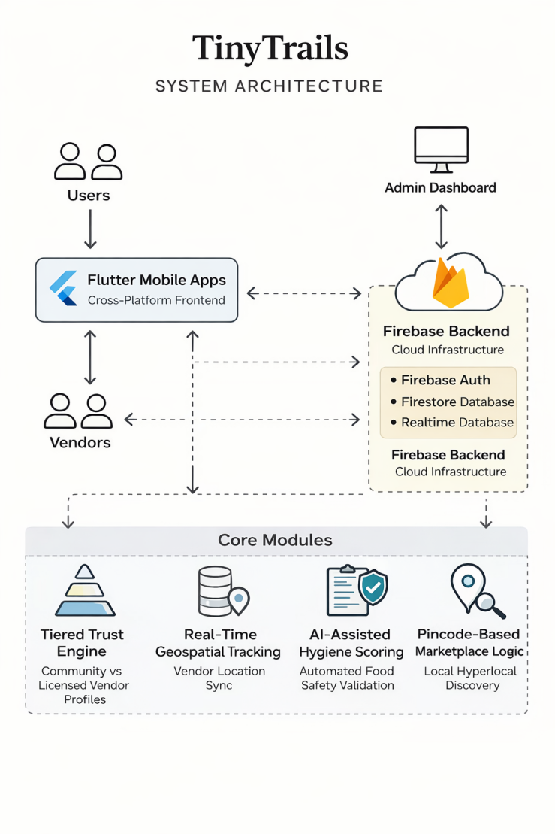
Firebase Realtime Database is employed for synchronizing real-time location updates for mobile vendors. In contrast to fixed stores, this enables the system to represent vendors as dynamic geographical objects. Using an in-built map interface, consumers interact with these real-time location updates, enabling real-time awareness and online hailing within a fixed operational range.Vendors operating in the food industry are required to go through an additional approval process. Vendors are required to upload photos of their workspace, which are then processed using an AI-enabled evaluation process before enabling daily listings. To enhance trust transparency, a hygiene confidence score is generated and associated with the vendor account. Perishable food items are also required to go through time-bound activation logic, automatically disabling listings once the inventory is depleted or availability windows expire.
Geographically informed product listing is ensured by the pincode-based discovery system. By enabling listings based on proximity and localized interaction metrics, neighborhood commerce cycles are reinforced, and costs are reduced.The TinyTrails system architecture builds a scalable and structured online space tailored specifically for illicit hyperlocal commerce by integrating geospatial intelligence, tiered trust systems, strategic food inventory management, and real-time synchronization in a serverless setup.
- METHODOLOGY
TinyTrails' functional system incorporates geolocation synchronization, localized discovery, and trust governance to ensure organized hyperlocal trade. The strategy ensures that there are controlled functional boundaries within a cloud-managed environment while ensuring the inclusive participation of diverse micro-entrepreneurs.
Vendors create accounts through the mobile app to begin the registration process. Credentials for identity verification and relevant business information provided by vendors are securely stored in the cloud database. The system assigns a trust level based on the level of verification provided. The level determines the vendor's presence in the market and functional reach. The system applies a tiered inclusion policy based on verification levels rather than applying stringent criteria for eligibility.
After registration, vendors create entries that are indexed based on pincode metadata and geographical locations. The search algorithm primarily relies on localized activity patterns and proximity to filter search results. This encourages community-focused trade and simplifies the delivery process by ensuring that customers interact with vendors within a constrained local proximity.
Location updates are periodically updated in the cloud database for vendors who work in mobile environments. The user application can now display real-time maps because of these changes. The vendor device receives a formatted notification when a user initiates a service request, and the status is immediately synchronized. This procedure converts unstructured street-level navigation into a structured model of digitally synchronized interaction.
The following functional controllers manage the system's main execution logic:

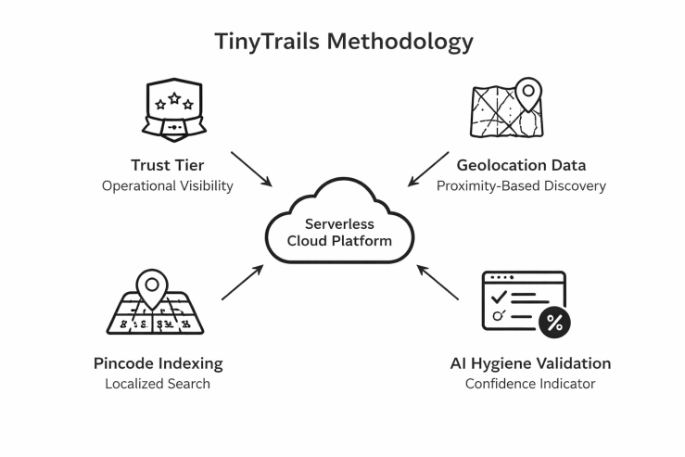
- Trust Tier → Defines the service radius and visibility.
During registration, a verification tier is assigned to each vendor. The verification tier defines the service radius, ranking, and visibility on the marketplace. It ensures that the operating rights are commensurate with the level of verification completed, thus maintaining organized participation in the system.
$$R_{T}=\left\{\begin{matrix}1 km, & T=1 (Community Verified Vendor) \\ 5 km, & T=2 (Licensed Vendor) \\ ∞, & T=3 (Pro Vendor)\end{matrix}\right.$$
$$D(v,c)≤R_{T}$$

- Geolocation Information → Enables proximity-based searching
Geographic location information is connected to vendor entries, enabling the system to filter results in real time based on geographical location. The system will only show the user results that are geographically relevant, based on the proximity of the user to the vendor. This will prevent unnecessary marketplace congestion and ensure proper hyperlocal engagement.
$$Rank(P_{i})=kF_{i}$$
- AI-Assisted Hygiene Validation → Boosts consumer confidence and transparency
The use of AI-assisted analysis can be applied to evaluate workspace or operational photos for relevant vendor categories. On vendor pages, a systematic confidence indicator is generated and displayed. This approach promotes transparency and well-informed decisions without restricting vendor participation.
$$H_{s}=\frac{\sum_{k=1}^{n}{I_{k}}}{n}×100$$
- Pincode Indexing → Enables localized search with a focus on - To enhance neighborhood-level segmentation, pincode metadata is employed for indexing every item. To guarantee that customers are mainly engaged with suppliers functioning in their immediate locality, search outcomes are modified according to pincode matching. Through this, the dominance of ranking superiority by a central authority is averted.
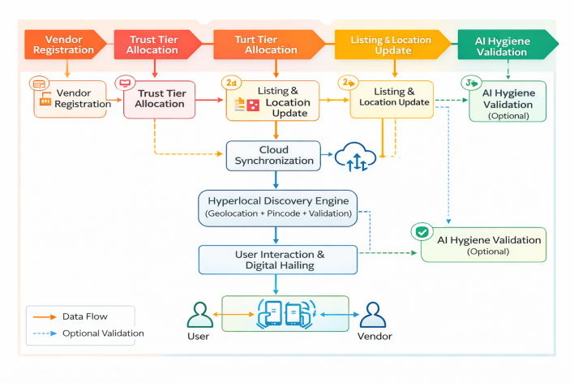
TinyTrails achieves scalable real-time vendor and user coordination by integrating these control mechanisms into a serverless cloud architecture. This solution provides a highly balanced framework that supports different types of vendors while ensuring organized administration and transparency in the workings of hyperlocal marketplaces.
- RESULT AND DISCUSSION
The design of a universal digital infrastructure that could potentially integrate unofficial micro-entrepreneurs into a structured hyperlocal market without enforcing rigorous regulatory constraints was the primary objective of TinyTrails. The performance of the system, the effectiveness of governance, accessibility, and transparency processes in controlled deployment settings were the primary points of investigation.
The robust rendering performance of the Flutter mobile framework on low-end and mid-range Android devices was demonstrated. During the pilot implementation, the continuous vendor location update without any latency was achieved through real-time synchronization using Firebase Realtime Database. In concurrent access conditions, the indexed querying process in Cloud Firestore ensured consistent response performance for efficient pincode-based product retrieval. The serverless Firebase environment enhanced the scalability and operational reliability of deployment and operation.
Without the need to set up rigorous eligibility criteria, the Tiered Trust Architecture facilitated gradual vendor integration. Operating within defined guidelines, vendors with partially filled regulatory paperwork could still participate. The system maintained accountability and structured inclusivity according to verification level through dynamic alignment of marketplace visibility and service area. Through reduced barrier entry, the tiered compliance approach encouraged increased digital participation among micro-entrepreneurs operating in the unofficial market.
Prioritizing simplicity, efficient navigation, and map-based discovery, the mobile interface was designed. Contextual user awareness in search and interaction was improved through the capability to distinguish static vendors from mobile operators through live geospatial display. For vendors with limited technical knowledge, simplified product listing procedures facilitated easier vendor onboarding. With prominent display of structured transparency indicators and trust levels on vendor pages, user interaction analytics indicated increased engagement.

- CONCLUSION
TinyTrails, a cloud-native, mobile-first hyperlocal marketplace platform, was proposed in this paper to digitally integrate the unofficial micro-entrepreneurs into the ecosystems of structured trade. TinyTrails proposes a governance model based on tiers in conjunction with geolocation synchronization and discovery, as opposed to the traditional marketplace platforms that rely on centralized logistics and rigorous enforcement of compliance.
The proposed Tiered Trust Architecture, based on matching operational visibility with verification level, overcomes the binary exclusion models with structured inclusion models for progressive vendor inclusion. Contextually relevant and geographically optimal marketplace interactions are ensured by the combination of real-time geolocation filtering and pincode-indexing. Additionally, structured confidence measures provided by AI-assisted transparency indicators enhance well-informed decision-making without compromising vendor accessibility.
The results indicate that operational logic and architectural redesign, rather than regulatory easing, can result in inclusive hyperlocal digital commerce. By using a lean architecture that incorporates cloud-based synchronization, trust management, and geographical filtering, TinyTrails provides a scalable platform suitable for micro-commerce scenarios in densely populated and semi-urban settings.
To enhance transparency and scalability further, future enhancements could include predictive demand analysis for micro-inventory optimization, multi-lingual voice interfaces, and advanced trust analytics.
ACKNOWLEDGMENT
The authors would like to thank Vel Tech High Tech Dr. Rangarajan Dr. Sakunthala Engineering College for their institutional support and academic guidance throughout the development of this project. The authors would also like to thank the technical resources and infrastructure that made the successful implementation and evaluation of the TinyTrails system possible.
REFERENCES
[1] A. S. Al-Adwan, “Impact of Delivery Apps Commission Rates on U.A.E Restaurants: An Economic Perspective,” IEEE Access, vol. 11, pp. 10531–10539, 2023.
[2] P. Gupta, “Exploring the Factors Shaping Customer Preferences in Online Food Delivery Apps,” IEEE Transactions on Engineering Management, vol. 70, pp. 11012–11025, 2024.
[3] M. A. K. B. M. Hanafiah et al., “Determinants of E-Commerce, Artificial Intelligence, and Agile Methods in Small- and Medium-Sized Enterprises,” in Proc. Of IEEE Int. Conf. on Computing and Informatics (ICOCI), 2023, pp. 120–125.
[4] S. Sharma and R. Kumar, “Zero Cost Online Food Delivery System with Machine Learning Prediction for Small Scale Vendors,” in Proc. Of IEEE Int. Conf. on Circuit Power and Computing Technologies (ICCPCT), 2023, pp. 1014–1021.
[5] S. P. Rahayu et al., “Women Entrepreneur Capacity Building toward Digital Economy Using an All-in-One eCommerce Platform,” in Proc. Of IEEE Int. Conf. on Cybernetics and Computational Intelligence (CyberneticsCom), 2022, pp. 1–6.
[6] A. Mendoza, E. Isasi-Perez, and J. A. Jung, “The Role of Digital Inclusion in the Digital Transformation of Micro-enterprises,” IEEE Access, vol. 10, pp. 12345–12356, 2022.
[7] M. Ali and F. Khan, “Efficient Food Delivery Management: Predicting Delivery Times for Improved Customer Experience,” in Proc. Of IEEE Int. Conf. on Data Science and Artificial Intelligence (DSAI), 2023, pp. 45–50.
[8] P. Kumar and S. Singh, “Mobile App for Tracking and Managing of Online Orders in E-Commerce Website,” in Proc. Of IEEE Int. Conf. On Computing, Communication and Networking Technologies (ICCCNT), 2024, pp. 1–5.
[9] G. Rejikumar, V. G. Venkatesh, et al., “Modeling and Analyzing Online Food Delivery Services Using Design Thinking: An Optimization Approach,” IEEE Transactions on Engineering Management, vol. 71, pp. 7913–7929, 2024.
[10] K. S. Bhat and J. Resnick, “Trust Mechanisms in Consumer-to-Consumer Electronic Markets,” IEEE Internet Computing, vol. 25, no.2, pp. 34–42, 2021.
[11] E. Yilmaz and O. Cakir, “Design and Implementation of a Customer-Interactive Cargo Delivery System: A Case Study,” IEEE Transactions on Consumer Electronics, vol. 69, no. 3, pp. 1126–1134, 2024.
[12] Z. Yan, P. Zhang, and A. V. Vasilakos, “Trust Management for Social Internet of Things,” IEEE Wireless Communications, vol. 21, no. 3, pp. 28–34, 2014.
[13] J. Doe et al., “Mobile Application for the Intelligent Management of Small Shops using the GPT-4 Model,” IEEE Access, vol. 12, pp. 10819–10830, 2024.
[14] A. G. Howard et al., “MobileNets: Efficient Convolutional Neu-ral Networks for Mobile Vision Applications,” arXiv:1704.04861, 2017.
[15] M. Loey, G. Manogaran, and N. E. M. Khalifa, “A hybrid deep transfer learning model for face mask detection in the era of the COVID-19 pandemic,” Measurement, vol. 167, p. 108288, 2021.
[16] L. Silva and M. A. R. Dantas, “Implementation of Delivery Application Using a Development Method for Mobile Applications,” in Proc. Of IEEE Latin American Conference on Computational Intelligence (LA-CCI), 2015, pp. 1–6.
[17] F. Khfer and S. M. A. Shah, “Performance Evaluation of SQL and NoSQL Database Management Systems in Windows Environment,” in Proc. Of IEEE Int. Conf. on Smart Cloud, 2020, pp. 145–150
[18] P. Gupta, “Exploring the Factors Shaping Customer Preferences in Online Food Delivery Apps,” IEEE Transactions on Engineering Man- agement, vol. 70, pp. 11012–11025, 2024.

